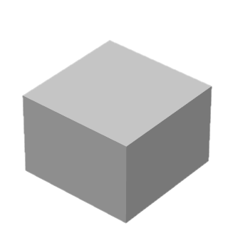 | ____ Layers Tilted  _____Upper Layers Deposited  _____Erosion  _____Lower Layers Deposited | 1.  2.  3.  4.
U-1 Draw Unconformity | U-2 Order Events | U-3 List Events
 | 1.  2.  3.  4.  5. | 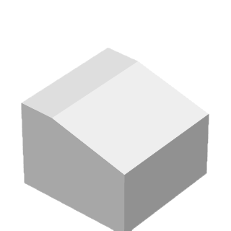
U-4 Draw Unconformity | U-5 List Events | U-6 Draw Unconformity
1.

2.

3.

4.

5.
U-7 Identify Layers/Draw Unconformity | U-8 Order Events | U-9 Draw Unconformity
 | 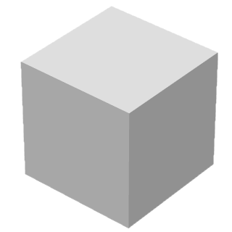
U-10 Describe and Order | U-11 Draw Block − Practice | U-11 Draw Block − Final

