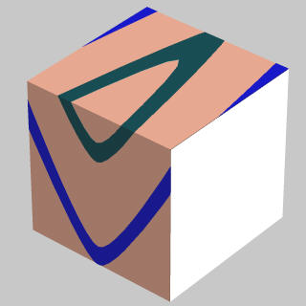 | 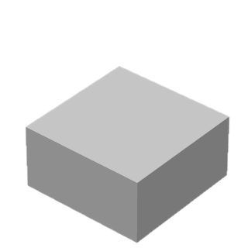 | 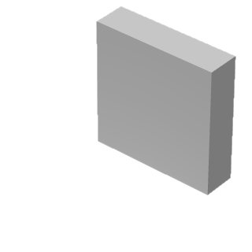
Fo-1 Sketch | Fo-2 Sketch | Fo-3 Sketch
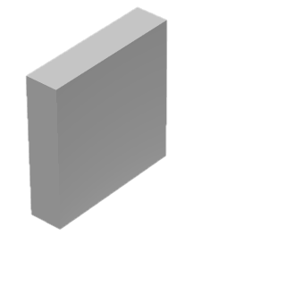 | 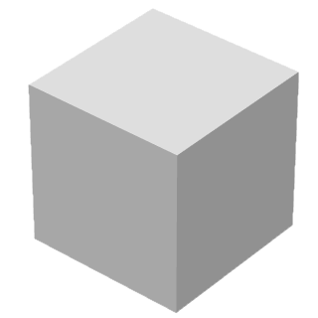
Fo-4 Sketch | Fo-5 Practice sketch | Fo-5 Final sketch

