L-1 Sketch | L-2 Sketch | L-3 Sketch
 | 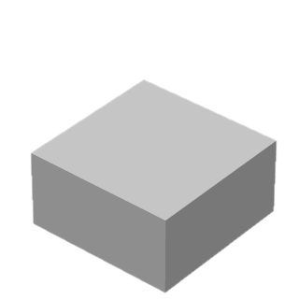 | 
F-1 Sketch | F-2 Sketch | F-3 Sketch
Direction of faulting:  Visual clues used: | 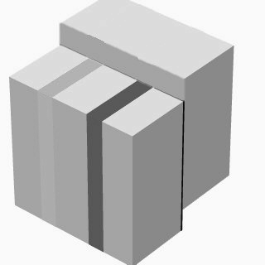
Ft-1 Describe | Ft-2 Sketch | I-1 Describe
1.

2.

3.

4.
I-2 List Order of Events (old to young)s (old | U-1 Sketch

